By sponsoring a seat – in our Main House or Studio - you will be helping Herefordshire’s Centre for the Arts remain sustainable into the future!
Seat sponsorships are acknowledged with a smart plaque, personalised with your chosen inscription on your preferred seat and last FIVE YEARS!

Studio seats are £200 each
Main House seats are £300 each (or £500 for a pair)
Please see overleaf for the application form to be handed into Box Office with payment. Alternatively, you can pay by standing order (please ask for form).

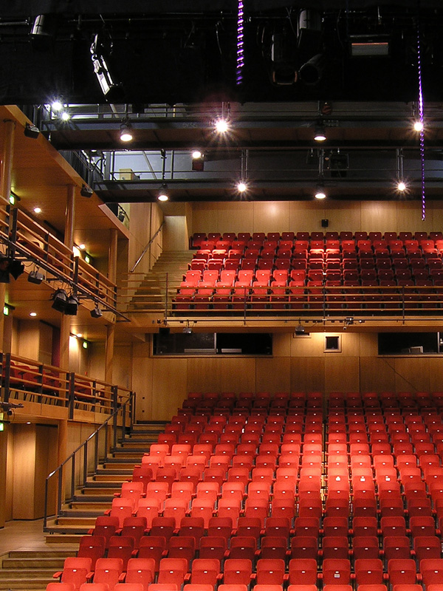

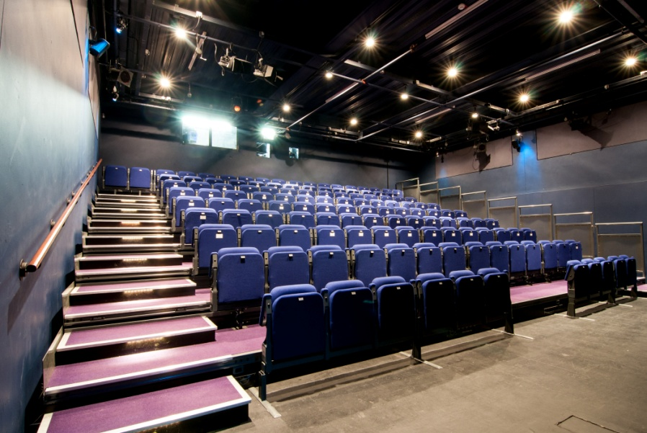

SEAT SPONSORSHIP APPLICATION FORM 2019-20

Full Name: _______________________________________________________________________
Address:__________________________________________________________________________
__________________________________________________________________________________
Telephone: _______________________________________________________________________
I wish to support _____ (number of) seats in the MAIN HOUSE (£300 each/£500 for a pair)
OR I wish to support _____ (number of) seats in the STUDIO (£200 each)

My plaque dedication (maximum of characters 50 including spaces between words)
e.g. The Jones Family, In Memory of Jack Smith:
__________________________________________________________________________________
__________________________________________________________________________________
I wish to donate an additional £_______ towards The Courtyard.

If you are a UK tax payer & can gift aid this/any other donations, please ask for
a Gift Aid form at Box Office or ask them to check if they’ve got a completed form
from you already if unsure.
To pay by cheque: Please make the cheque payable to The Courtyard Trust.
To pay by credit/debit card: Please call box office on 01432 340555.
To pay by standing order, please tick here
and ask for a standing order form from Box Office which should be completed and accompany this booking form. (MAIN HOUSE: £30 a month x 10 mths or £50 a month x
10 months (for two seats) OR STUDIO: £20 a month x10 mths)

Please hand in this form to Box Office or post to: Melanie Denning, Fundraising Manager,
The Courtyard, Edgar Street, Hereford HR4 9JR. On receipt of the completed application form and standing order form (if applicable), we will contact you to confirm your booking and dedication.

For further information on supporting The Courtyard, please call Melanie Denning
on 01432 346503 or email melanie.denning@courtyard.org.uk
Many thanks for your support!

