Activity Three: The Characters

This activity will help us to discover more about our favourite characters from Roald Dahl’s stories!

- Pick your favourite character and complete the character profile
  - If you have time, can you make a profile for any other characters?
  - Try and use lots descriptive words and adjectives to help your characters come to life!

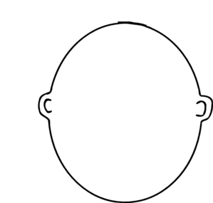
- Character Profile
Characters Name: ........................................

Characters Age: .......................

Physical Description of Character:
..................................................................................................................................................................................................................................................................................................................................................................................................................................................................

List five adjectives to describe this character’s personality:
.............................................................................................................................................................................................................................................................................................................................................................................................................................................................
Where does this character live?
..........................................................................................................................................................................................................................................................................................................................................................................................

How do other characters react to this individual?
................................................................................................................................................................................................................................................................................................................................................................................................................
Create a catchphrase for your character:
................................................................................................................................................................................................................................................................................................................................................................................................................

