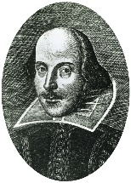
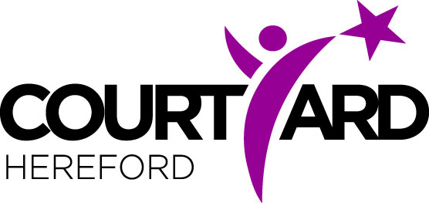
A Midsummer Night’s Dream Character Design
Can you complete this sheet for your favourite character in
I would describe my character as…
A Midsummer Night’s Dream?
My name and class…

In their spare time, they like to…
My character is called ….

This is what my character would look like!

