**Adopt A Seat 2024**

By adopting a seat in our Main House or Studio Theatre, you can make a very visible show of support for our fantastic arts charity.

Adoptions are acknowledged with a plaque personalised with your chosen inscription on your preferred seat for 1-3 years, depending on the package you choose. For an extra £30 per seat, you can upgrade to a silver plaque, celebrating our 25th anniversary year 2023-24.

**Packages**

**Studio Main House**

£200 pa £300 pa

£500 for three years £750 for three years

Seat adoption fees are donations so if you can Gift Aid your donation, please let us know.

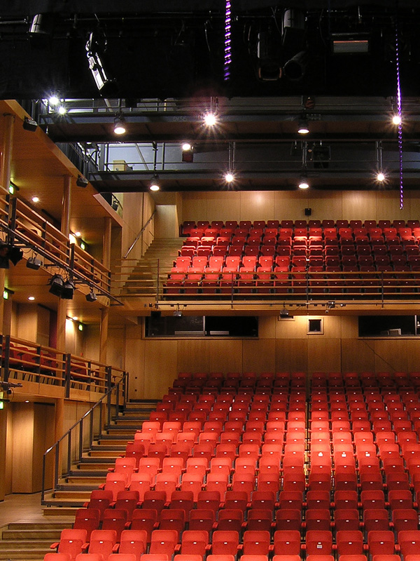

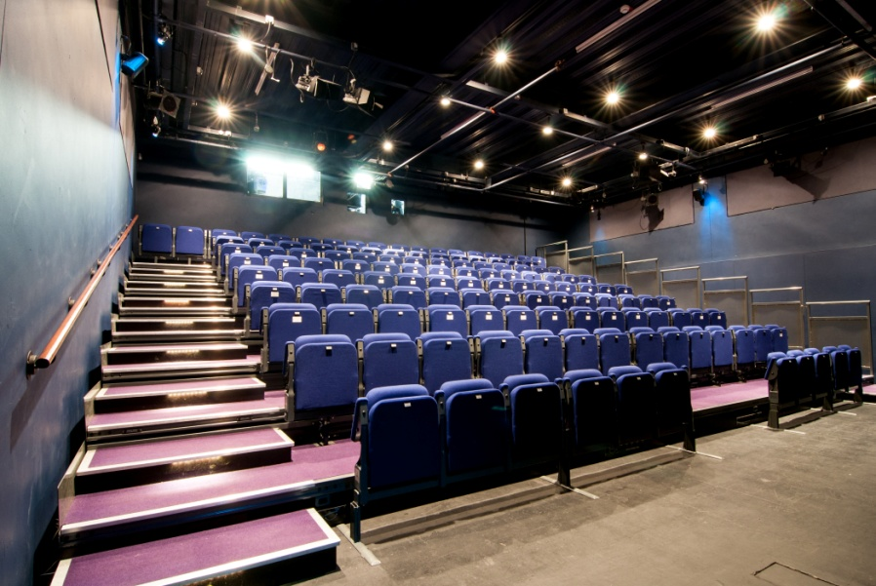

If you would like to adopt a seat, please fill in the form and return it to:

Melanie Denning, Head of Fundraising, The Courtyard, Edgar Street, Hereford, HR4 9JR or email melanie.denning@courtyard.org.uk

**Adopt a seat application form**

**Full Name: _______________________________________________________________________**

**Address:__________________________________________________________________________**

**__________________________________________________________________________________**

**Telephone: _______________________________________________________________________**

**I wish to adopt _____** (number of) **seats in the Main House** (£300 1 year/£750 3 years)

**I wish to adopt _____** (number of) **seats in the Studio** (£200 1 year/£500 3 years)

Total payable: ___________

**My plaque dedication (maximum of characters 50 including spaces between words)**

**e.g. The Jones Family, In Memory of Jack Smith:**

**__________________________________________________________________________________**

**__________________________________________________________________________________**

**I wish to have _____ silver plaque(s) at an additional cost of £30 per seat**

If you are a UK taxpayer & can gift aid this or any other donations, please ask Box Office   
for a Gift Aid form or ask them to check if we hold a valid Gift Aid form in your name.

**To pay by cheque:** Please make the cheque payable to The Courtyard Trust.

**To pay by credit/debit card:** Please call box office on 01432 340555.

**To pay by standing order,** please tick here

Ask for a standing order form from Box Office or download the form which should be completed and accompany this booking form.

Main House: £30 a month x 10 months (1 year fee) or £75 a month x 10 months (3-year fee)

Studio: £20 a month x10 months (1 year fee) or £45 a month x 10 months (3-year fee)

**Please hand in this form to Box Office or post to:** Melanie Denning, Head of Fundraising,   
The Courtyard, Edgar Street, Hereford HR4 9JR. On receipt of the completed application form and standing order form (if applicable), we will contact you to confirm your booking and dedication.

For further information on supporting The Courtyard, please call Melanie Denning  
on **01432 346505** or email melanie.denning@courtyard.org.uk

**Thank you for your support!**