Our News 4 Youths newsletter is the best place to find out what’s going on in Youth Theatre! From upcoming performances, events, socials and shows we recommend, make sure you’re up to date on all things **YOUTH THEATRE!**

**Come here for the latest Youth Theatre news! Brought to you by the Youth Board**

News 4 Youths

Youth Board

**For this newsletter Chloe and Lily give us an update on the senior youth theatre! Also, Isaac lets us know how the Junior Youth Theatre’s showcases went.**

*Seniors Uncovered with Chloe and Lily!*

*Currently in the senior youth theatre we have been working towards our big production of Dorian Gray. We having been busy with devising scenes, with a modern twist, from the book in order to create our own script. Throughout the Easter holidays we were busy reading through our first draft and doing some filming/photography for the digital element that we will be including. The filming and photography went amazing! And now we are thrilled to get back to work on blocking our show. We are so excited to get this performance on the main stage for you all to see.*

*Isaac’s Junior*

*Through the term the Junior Youth Theatre were doing famous fables such as Belling The Cat and other stories like The Lion and The Mouse. They did wonderfully in the showcase and in rehearsal. They were good as gold and did not cause any trouble at all. All the audiences left very happy with the performances!*

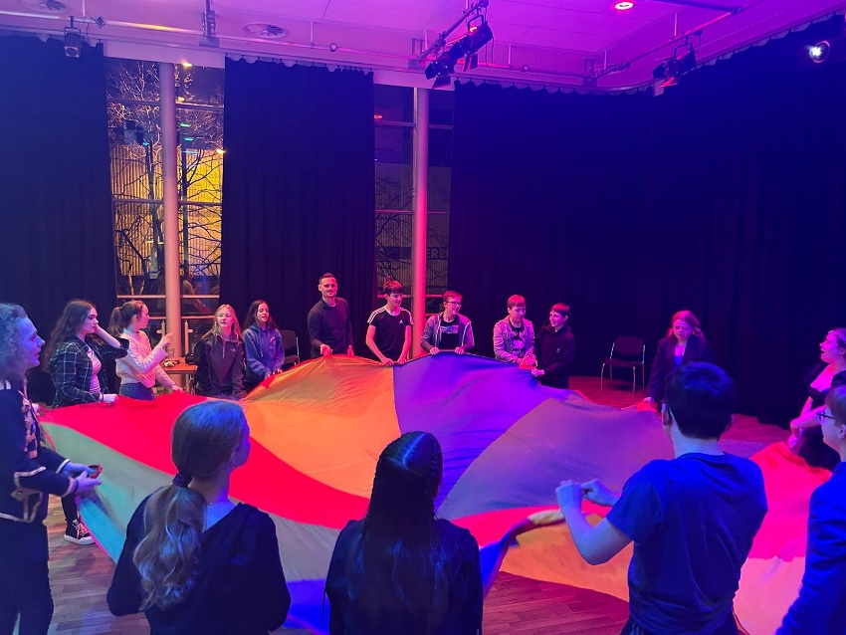

Youth Theatre Socials Update

*Last month the youth board social was an absolute success, bringing in a few dozen youth theatre members. There was lots of fun, a quiz and even a games corner where members played such classic games as Mario Kart 64. And the parachute brought smiles to everyone’s faces! The socials are a great way to make friends… and a moo off is promised, in which the winner is promised a top prize! Hope to see you there!*

**Details for upcoming socials at the bottom of the newsletter**



Matty’s Communities Roundup!

Courtyard Quiz!

This letter’s quiz is all based around musicals!

1. What is Shakespeare’s oldest play?
2. Which of these shows is NOT currently on in the West End? Six, Hamilton, Les Mis or Heathers?
3. What is the oldest theatre in London?
4. What is the longest running musical in the West End?
5. What building used to be where the Courtyard is now?

Email your answers to [jamie.hutton@courtyard.org.uk](mailto:jamie.hutton@courtyard.org.uk) Correct answers will be entered into a draw to win a free meal at the Courtyard Café!

**SPARK and IGNITE festival!**

***What is it?*** Our annual Youth Theatre festival which gives Youth Theatre members from across all our venues the chance to take part in workshops and perform together at the Courtyard. SPARK is for our Junior members and IGNITE for Year 7+

***When is it?*** Sunday July 14th. SPARK in the morning and IGNITE in the afternoon.

***What is this year’s theme?*** You’ll have to check the MySchool app and watch the launch video to find out!

*For more info just ask a youth theatre leader!*

**Other news!**

* **Everybody’s Talking About…. Jamie’s Picks!** These are the films that we recommend you see coming up at The Courtyard! *Pepper & Honey (pay what you decide), Mi Flamenco, Dorian Gray!*
* Plus our exciting SENIORS ONLY social, **Olive Boy – May 23rd**
* As well as some spellbinding magic at our next big social, in May half term, **Morgan & West – May 28th**
* And keep your eyes peeled for our next Youth Theatre fundraising event! We’ll be raising money very soon for our **throw a sponge event** at this year’s SPARK and IGNITE

*If you have any news you want to share with the Youth Theatre please email* [*jamie.hutton@courtyard.org.uk*](mailto:jamie.hutton@courtyard.org.uk)

*Caption this photo!*